Eco Paw

A Web Design Development Project
Presented to
the Faculty of the College of Computer Studies
Our Lady of Fatima University

In Partial Fulfillment
of the Requirements for the
WBDV111 – Web Development with Lab I

by
Yuan Mikiel F. San Diego

May 2026

TABLE OF CONTENT

Title Page …………………………………………………………… i

1 | Executive Summary
 | 1.1 Project Overview | 1
 | 1.2 Target Audience | 2
 | 1.3 Project Objectives | 3
 | 1.4 Statement of the Problem | 4
 | 1.5 Scope and Limitations | 5
2 | Introduction and Project Background
 | 2.1 Business or Company Profile | 6
 | 2.2 Rational of the Web Design Project | 7
 | 2.3 Significance of the Project | 8
3 | Planning and Design
 | 3.1 Website Category and Concept | 9
 | 3.2 Design Goal and Visual Strategy | 10
 | 3.3 Site Map and Information Architecture | 11
 | 3.4 Wireframe and Page Layouts | 13
 | 3.5 Navigational Design | 14
4 | Design Implementation
 | 4.1 Homepage Design | 15
 | 4.2 Inner Pages Design | 20
 | 4.3 User Interface Design Elements | 21
 | 4.4 User Experience Consideration | 22
 | 4.5 Branding and Visual Consistency | 23
5 | Summary, Reflection and Recommendations
 | 5.2 Project Summary | 24
 | 5.2 Self- Reflection | 25
 | 5.3 Future Design Improvements | 26

1. Executive Summary
1.1 Project Overview: Eco Paw is an online platform for the display and sale of a range of dog food products. The website offers users an easy and convenient way to browse products, learn about dog nutrition and place orders online. It has important features like product listings, user accounts and an ordering system.
1.2 Target Audience: It is aimed at dog owners and pet lovers who want to find easy and reliable ways to buy quality dog food online. It is specifically designed for busy people who prefer to shop online and first-time pet owners who need guidance on the right nutrition for their dogs.
1.3 Project Objectives:
- To design a user-friendly and visually appealing website
- To provide detailed information about dog food products
- To create a functional ordering system
1.4 Statement of the Problem: It is hard for many dog owners to find quality dog food from reliable and accessible sources. Some online sites can be hard to use and physical stores may have limited selections. This project aims to address these issues by creating a central, easy-to-use website.
1.5 Scope and Limitations: This project describes the development of Eco Paw with product pages, login and registration of users and a basic ordering system.
2. Introduction and Project Background
2.1 Business Profile: Rascal’s Raw Bulacan, established in 2024, is a trusted supplier of affordable and high-quality raw ingredients for dogs. We are committed to providing pet owners with safe, nutritious, and responsibly sourced products that support the health and well-being of their furry companions.

2.2 Rationale of the Web Design Project: This project was made because more and more people are shopping online. Pet owners like convenience, and a website lets them look at and buy things whenever they want.
2.3 Significance of the Project: This project is important because it gives dog owners an easy way to find and buy good dog food while providing better pet care.
3. Planning and Design
3.1 Website Category and Concept: The site is an e-commerce site. Its idea is based on being simple, easy to use, and pet-friendly, with warm colors and clean layouts
3.2 Design Goals and Visual Strategy: The goal of the design is to make a website that is clean, easy to use, and looks good by using warm colors, simple fonts, and well-organized layouts.
3.3 Site Map and Information Architecture:

General View Dashboard Sitemap
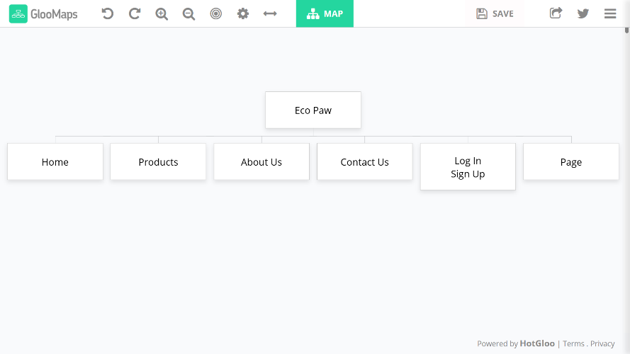

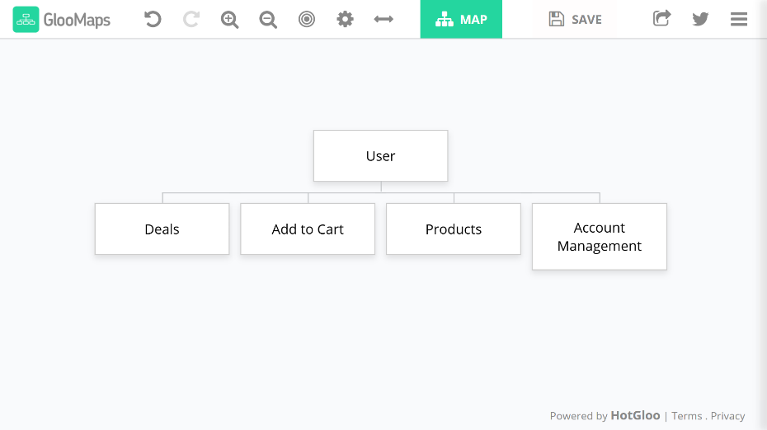
User Dashboard Sitemap

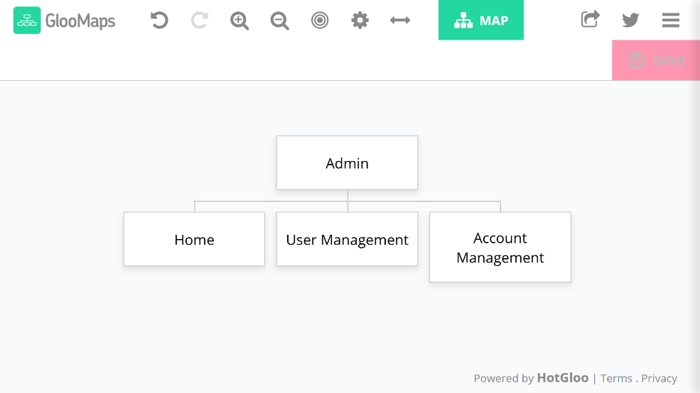
Admin Dashboard Sitemap

3.4 Wireframes and Page Layouts:
Wireframes
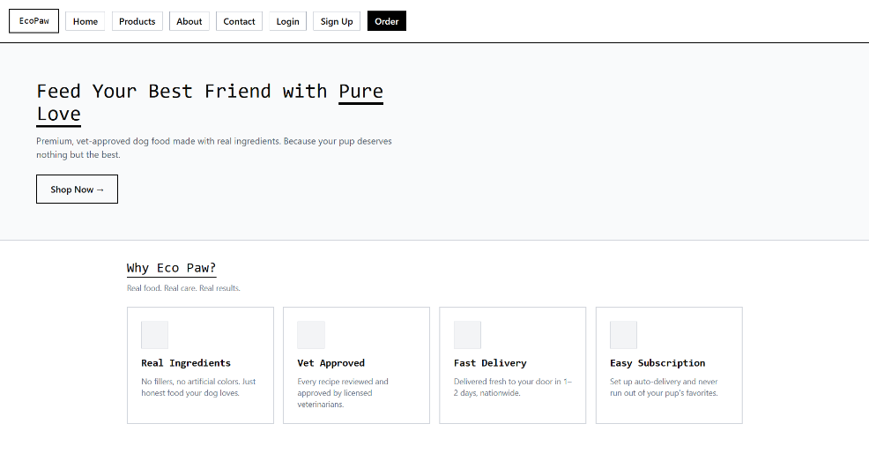

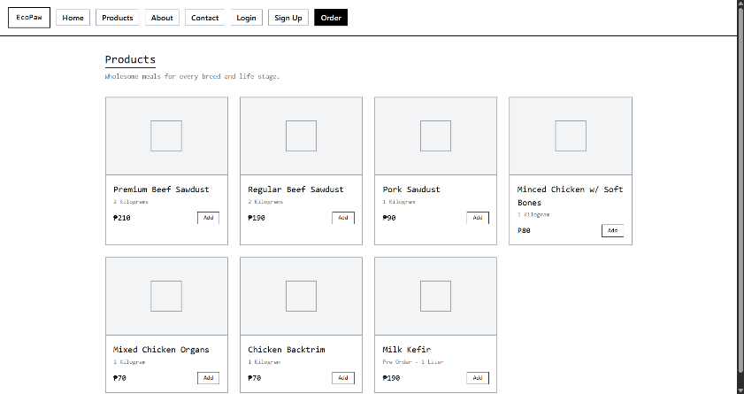

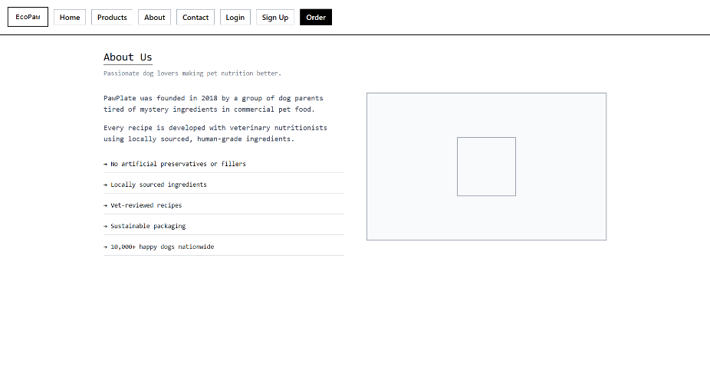

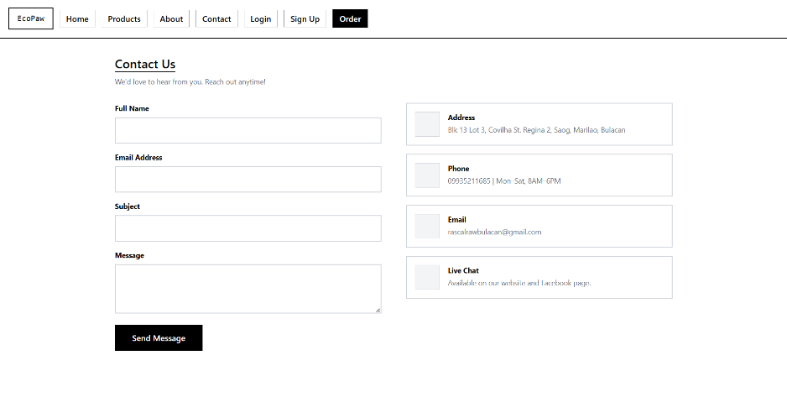

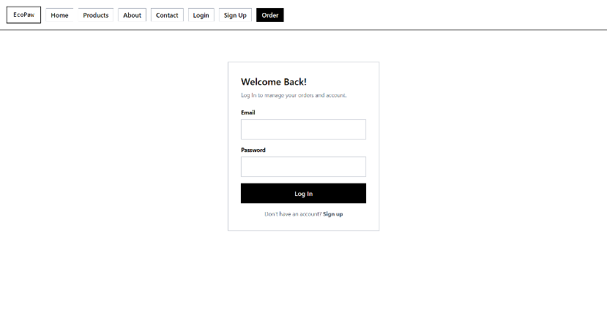

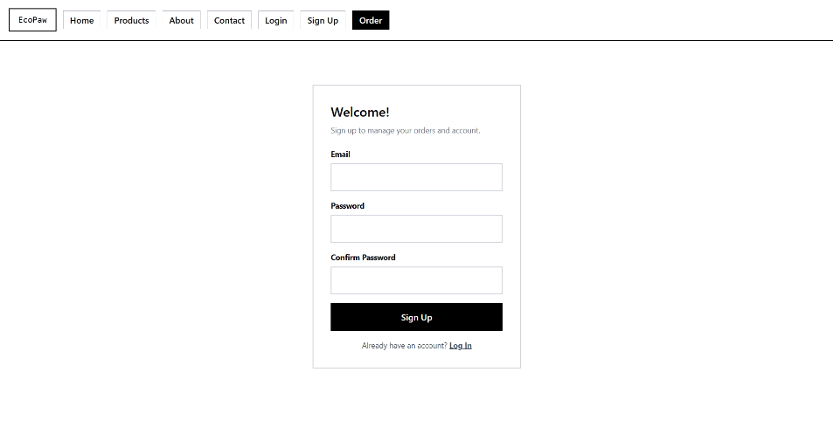

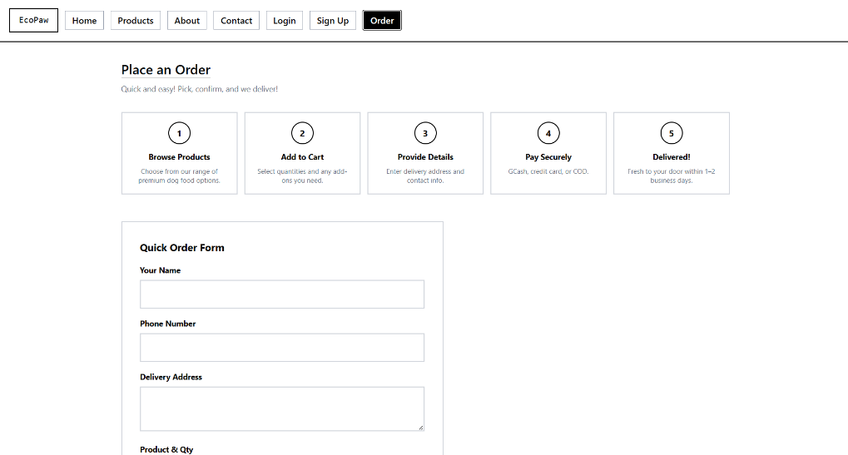

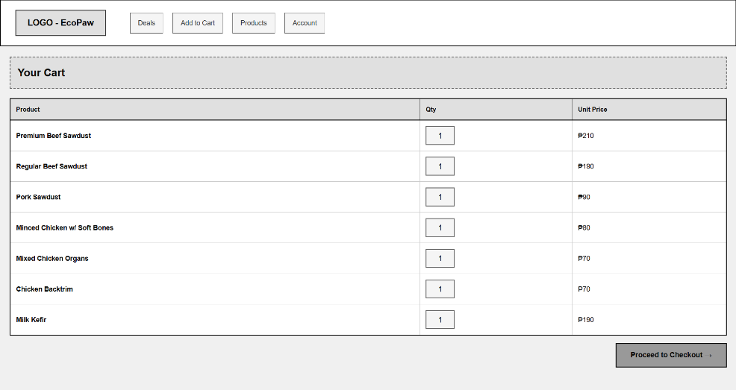
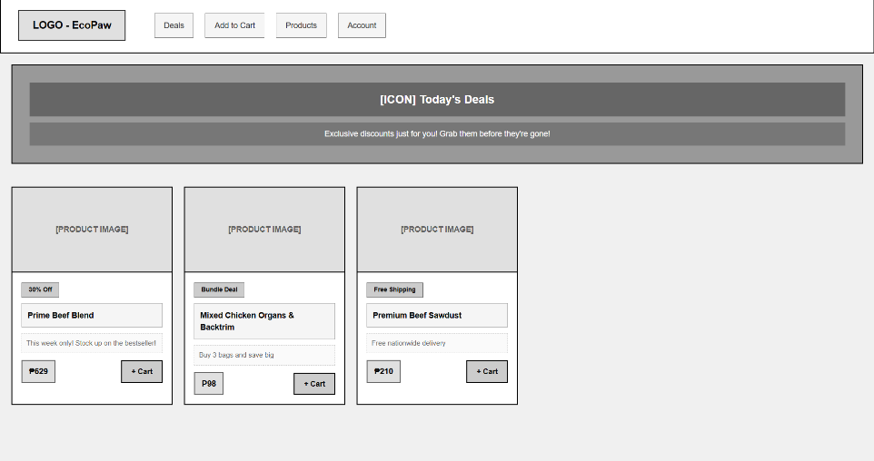

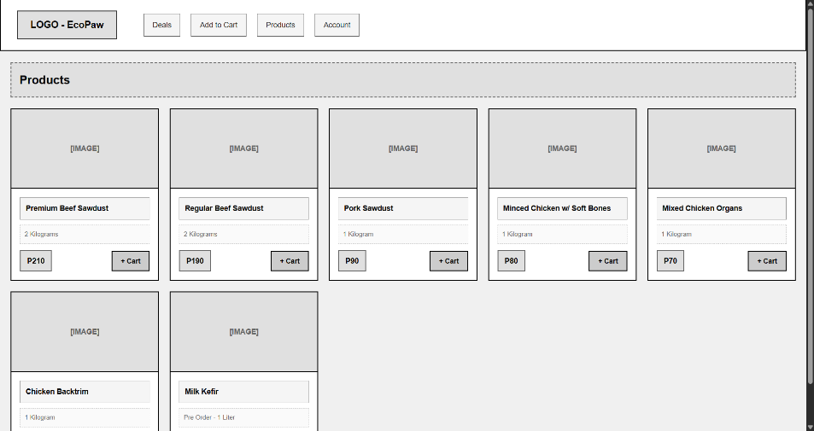

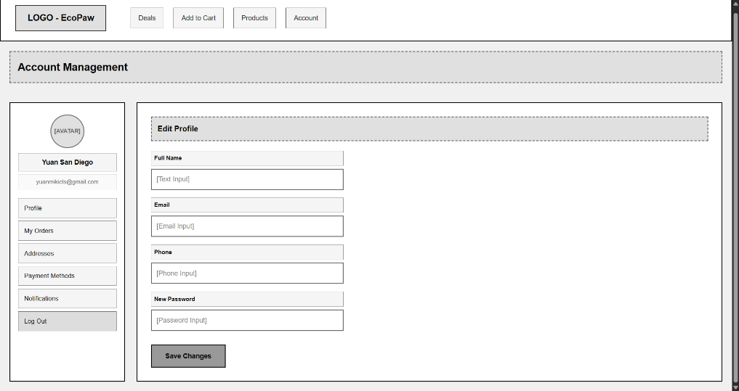

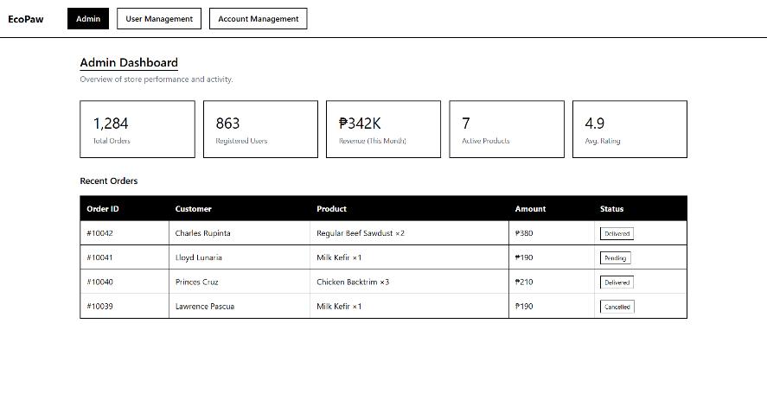

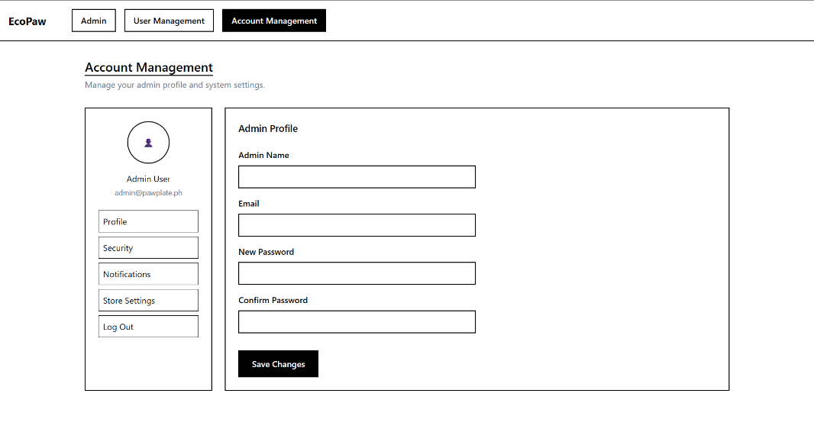
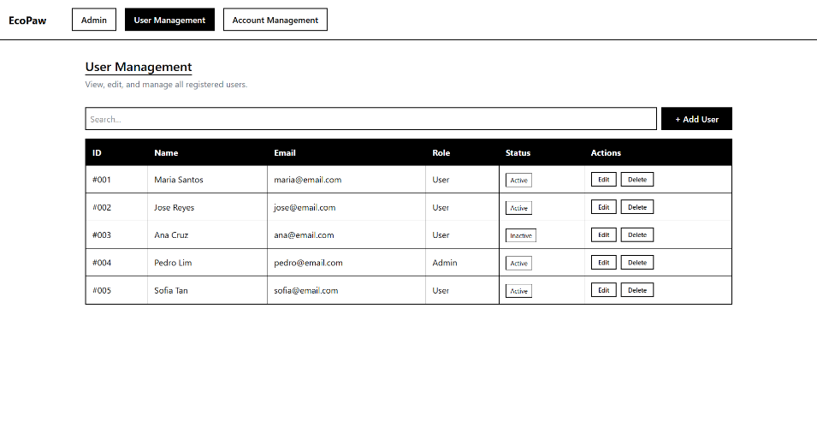

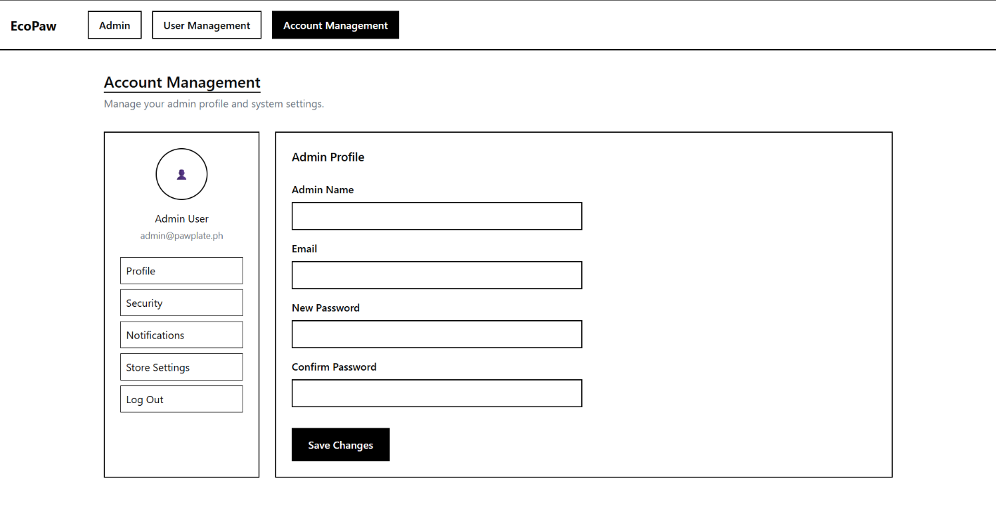

3.5 Navigational Design: The navigation bar is located at the top of each page for easy access. The buttons are clearly labeled so users can easily navigate between pages without any confusion.
4. Design Implementation
4.1 Homepage Design: The homepage is designed to make the first impression with a welcoming banner, a clear navigation menu, and dog food products highlighted. It gives easy navigation to the key sections of the site while maintaining a clean, attractive design to help the visitors navigate through the site easily.

4.2 Inner Pages Design:
Home: Returns to the main landing page
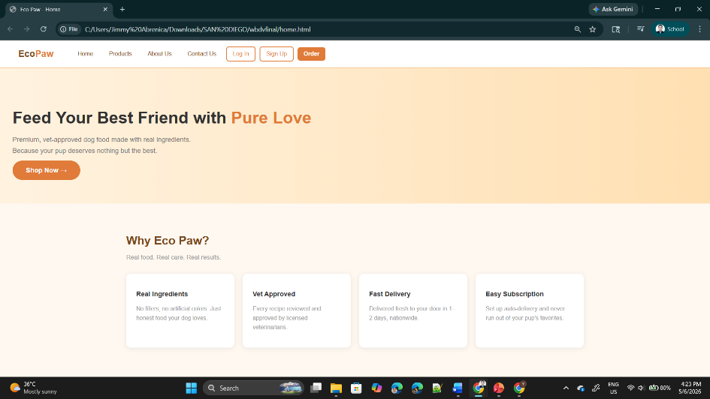

Products – Displays the full catalog of available dog food items with names, weights, and prices.
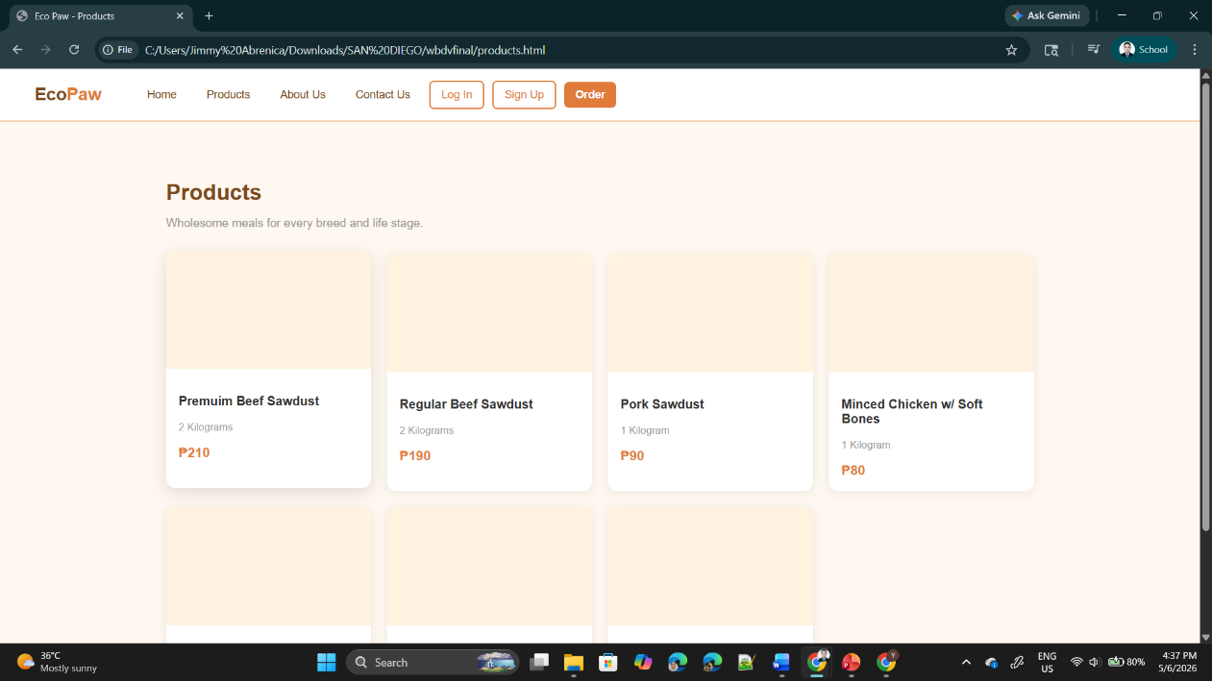

About Us – Shares the story and mission behind Eco Paw.
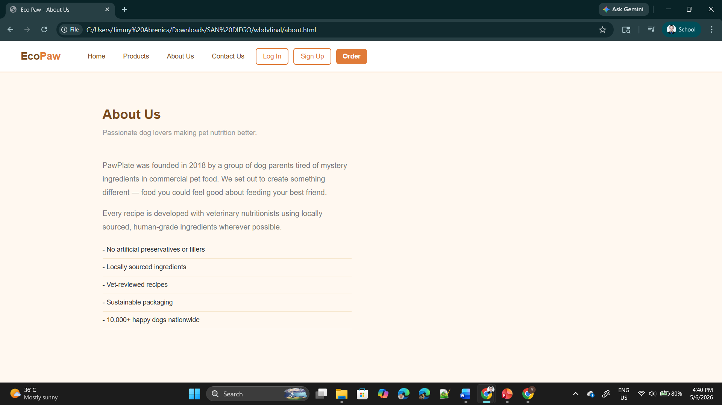
Contact Us – Provides a message form along with the business address, phone number, and email.
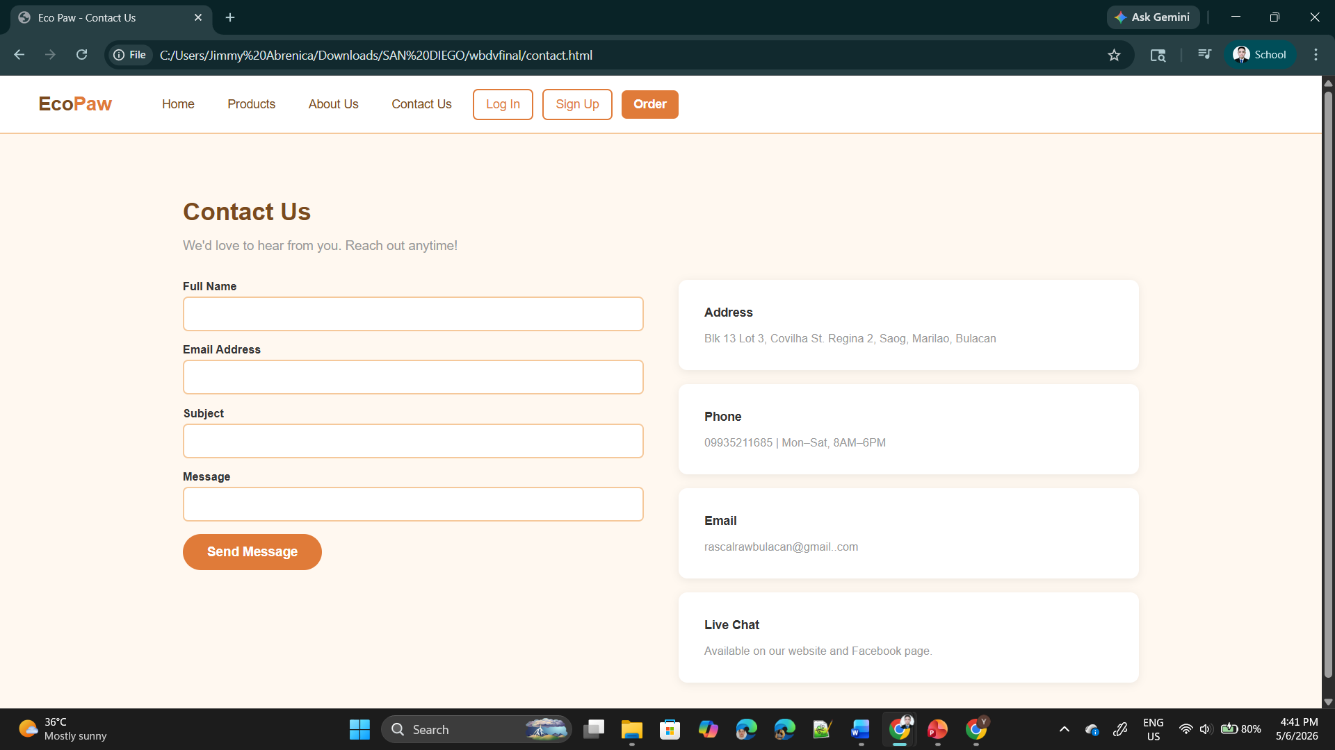

Log In – Lets returning customers access their account to manage orders and personal details.
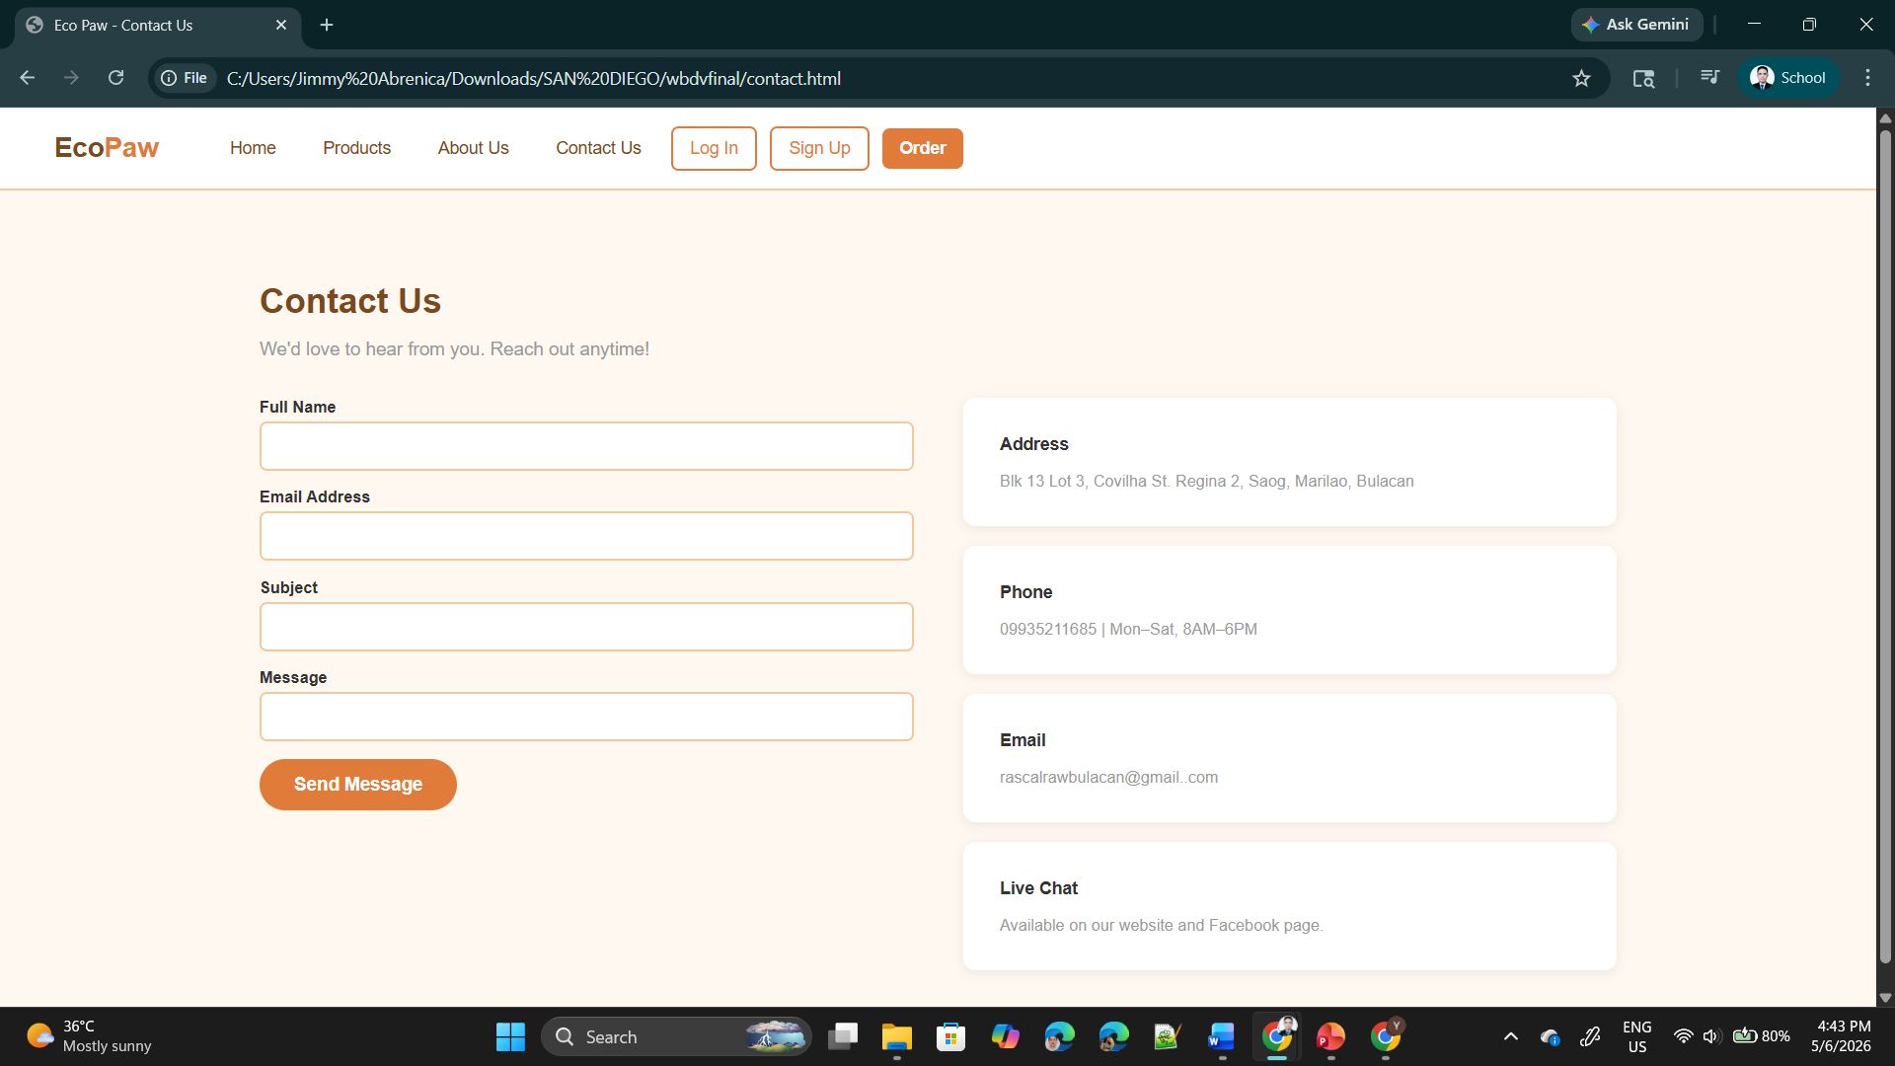
Sign Up – Allows new customers to create an account with their email and password.
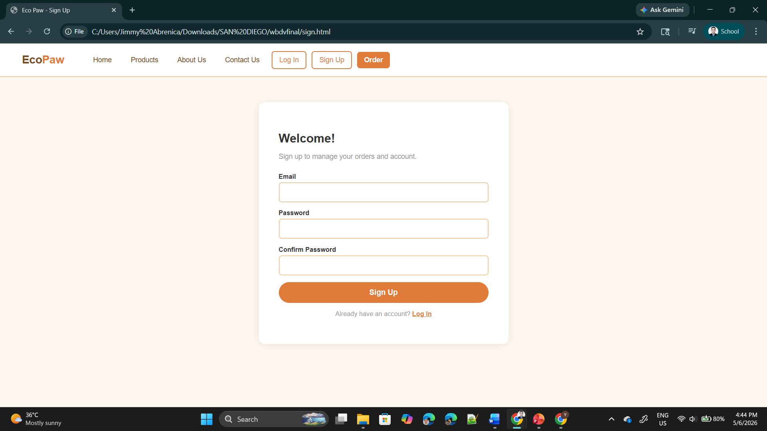

Order – Takes customers to a quick order form where they can fill in their name, contact, address, and desired products for delivery.
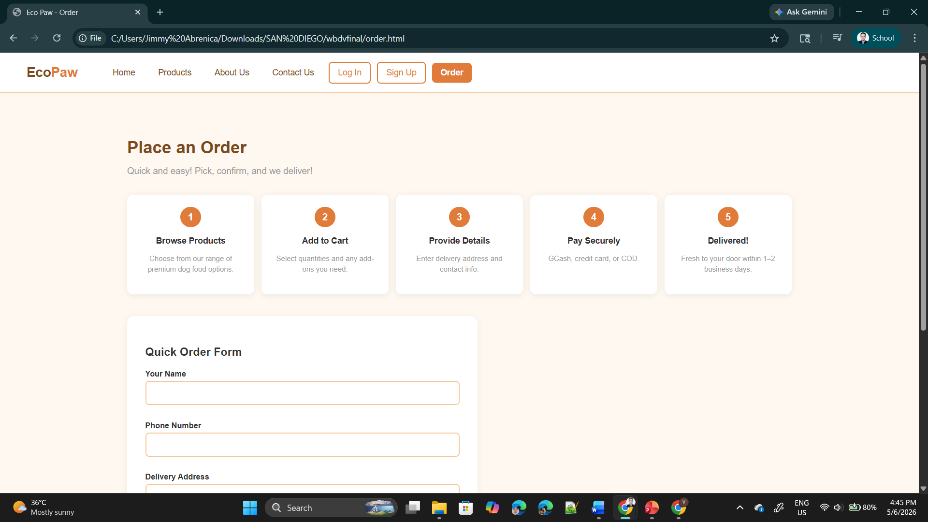

4.3 User Interface Design Elements: The design includes buttons with hover effects for better interaction, product cards and forms for login and sign-up for managing user access. The interface uses a uniform color scheme to ensure a consistent and attractive user experience.
4.4 User Experience Considerations: The website is designed for a smooth and enjoyable user experience with easy navigation, fast loading pages and easy access to information. It focuses on easy and simple to use, enabling users to browse products and complete tasks with no difficulty.
4.5 Branding and Visual Consistency: The website maintains a strong branding and visual consistency by using the same color scheme, fonts, and design elements in all pages. This creates an overall appearance that enhances Eco Paw's brand and makes the website look more professional and attractive.
5. Summary, Reflection, and Recommendations
5.1 Project Summary: The Eco Paw Dog Food Shop website is designed to provide an easy and convenient place for people to look at and buy good dog food. It improves the user experience by making navigation easy, organizing content, and making the design look good.
5.2 Self-Reflection: This project helped me learn more about how to design websites and how to organize content well. I learned how important layout, consistency, and the user experience are to creating a website work.

5.3 Future Design Improvements: Adding more interactive features, making it more mobile-friendly, and giving it a more modern look are all things that could be done to improve the Eco Paw website in the future. It could also become a fully functional online store by adding a database system, user reviews, and a secure payment option.

1. The Creative Process
- Why did you choose this specific category for your website?
I chose the dog food shop category because it meets the growing need for easy and reliable access to quality pet food. Many pet owners like to shop online because it's easy to compare products and make smart choices. This category also lets you make a useful and easy-to-use website that helps people learn about pet care and makes it easy to shop online.
- What part of the design are you most proud of?
The overall layout and navigation of the website is what I'm most proud of about the design. It is clean, organized, and simple to use, which makes it easy for users to find products and get to important pages.
2. Technical Growth
- Which CSS property or HTML tag was the most difficult to master, and how did you figure it out?
The hardest part to learn was how to style positioning and layout, especially how to put things in the correct position on the page.
- If you had 48 more hours to work on this site, what advanced feature would you try to add?
I would include user accounts with order tracking so customers can monitor their purchases.
3. Problem Solving
- Describe one specific "bug" or error you encountered. What steps did you take to fix it?
One problem I had was that the navigation menu didn't stay in the right place when the screen size changed, which made some buttons overlap or move out of place. I’ve fixed it by looking at the layout structure, changed the spacing and alignment settings, and tried different screen sizes to see how the parts worked. After making regular changes, the navigation became stable and responsive all over the page.
- During the testing phase, what was one thing you realized you needed to change to make the site better for users?
I learned during the testing phase that the layout needed better spacing and clearer separation between sections to make it easier to read.

4. Future Outlook
- On a scale of 1–10, how confident do you now feel writing HTML and CSS from scratch? Why?
On a scale of 1 to 10, my confidence is 4. I know how to make simple website structures and apply basic styles, but I still find it hard to make layouts from scratch and keep the design consistent and in the right place.

5.3 Future Design Improvements:
- Add a responsive design to make the website work better on mobile devices.
- Improve the layout and visuals to make the site more modern and attractive.
- Add advanced features like a shopping cart, user reviews, and order tracking.

